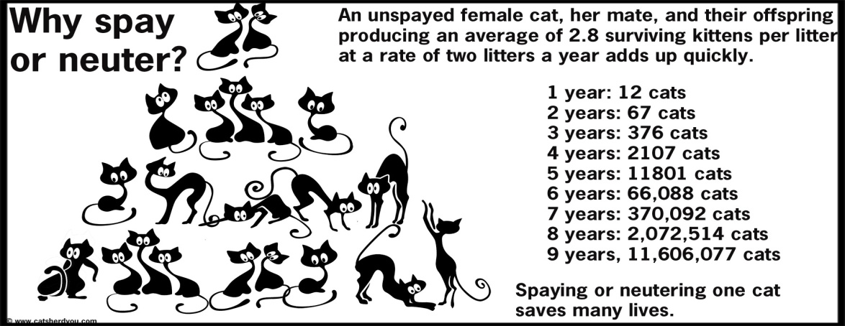

**Neutering (Castration): Benefits in Cats**

Other than population, there are lots of very good reasons to neuter (remove the testicles) from male cats. They basically fall into one of two categories - either behavior or medical. Regardless of which category we are talking about, most of the unwanted characteristics or conditions are caused by the male hormone testosterone, which is produced within the testicle.

**Decreased Aggression:** The (male) androgen hormones, of which testosterone is the most important, are responsible for the development of many behavioural patterns. Testosterone greatly affects aggression in cats. One of the most important behavioural advantages of castration is that as adults, these neutered cats tend to be less aggressive towards other cats.

**Decreased Spraying:** Spraying urine is a normal sexual behavior of unneutered male tomcats. Anyone who has smelled tomcat urine will quickly agree that spraying is a very unwanted behavior. Some castrated males will spray, but is much more uncommon in unneutered males.

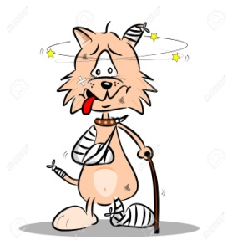**Decreased Roaming:** Another behavior advantage of neutering is that neutered cats are much less likely to react when they sense a female in heat through pheromones. These are airborne chemical attractants that are liberated from the female when she is cycling. They travel through the air for a great distance. Male cats neutered at an early age will generally not sense or respond to pheromones, and would certainly be less stressed and tend to stay home if they are outdoor cats.

**Reduced injuries:** The biggest medical advantage to neutering cats is really related to their behavior. Unneutered male cats fight to defend their territory. Such fights can be extremely serious, as abscesses often develop from bite wounds. Veterinarians have seen many tomcats who are missing parts of their ears and tails, or have faces with multiple scars resulting from the fights they had with other toms. Indoor, neutered cats lead much healthier and longer lives.

The behavior and medical problems caused by testosterone are common. Veterinarians deal with them on a daily basis. We do not want to see your pet suffer from a medical or behavior problem that could have been prevented through neutering.